**SECTION 2**

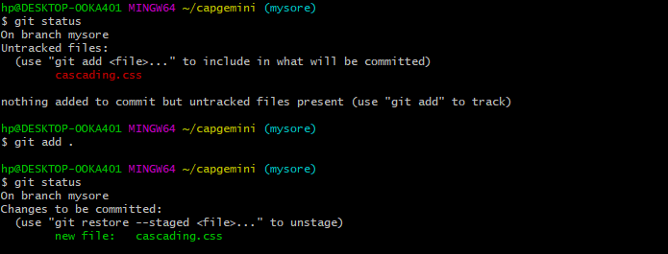

**Creating a new branch with css**

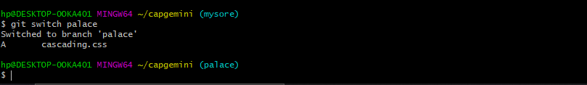

**Switching css**

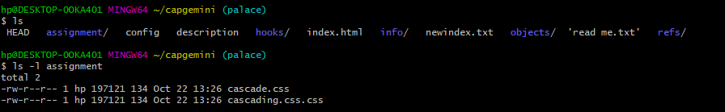

**copying data into assignment**

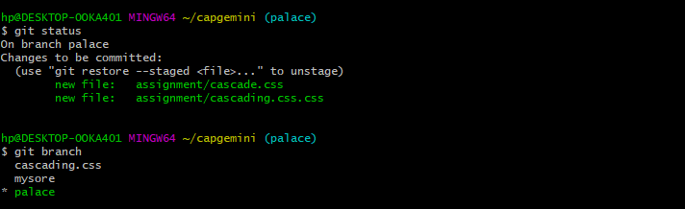

**Css branches**

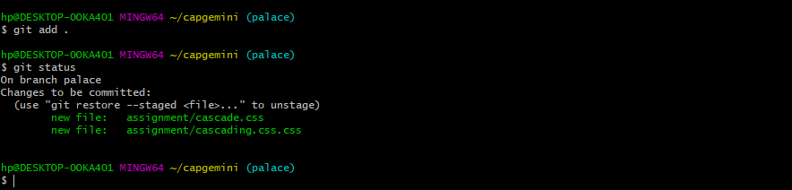

**Commiting css**

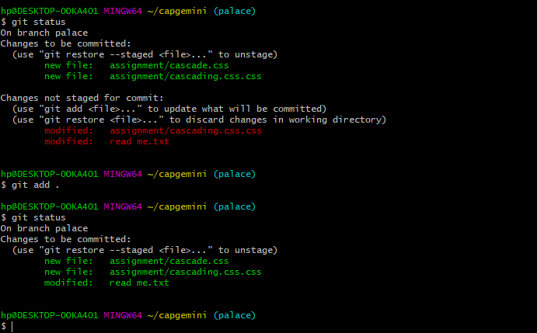

**Changes made and commited**

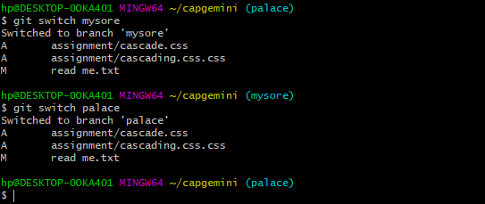

**Switching into the main branch**

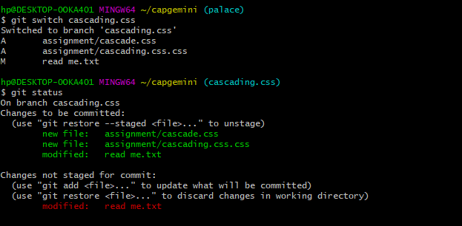

**Made changes**

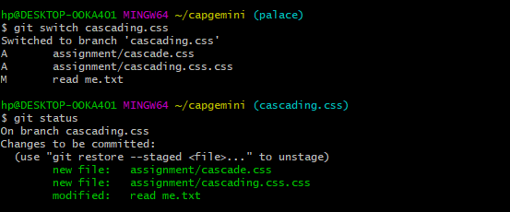

**Switched to cascading**

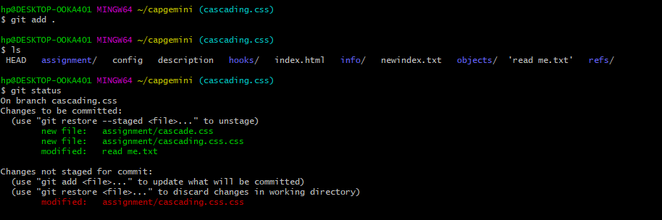

**Made changes in file under cascasding branch**

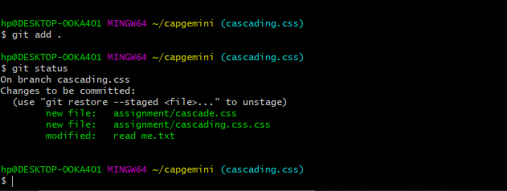

**Commited the changes made**

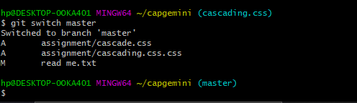

**Switching back to masters**

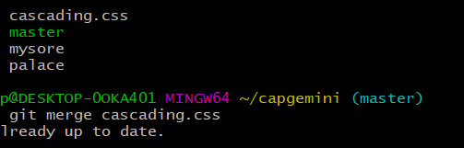

**Merging**

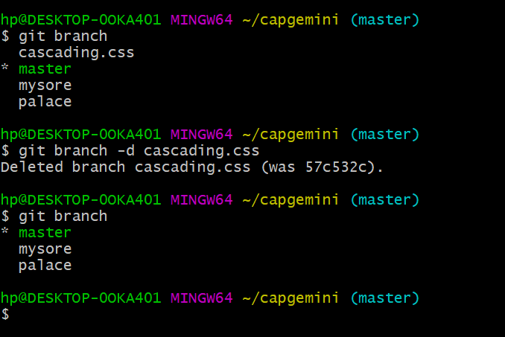

**Finally deleted cascading.css**